Coursework Portfolio 2

Sandbox application

Kolli bhavya sri

Student id: A00037677

1.NETWORK DIAGRAM

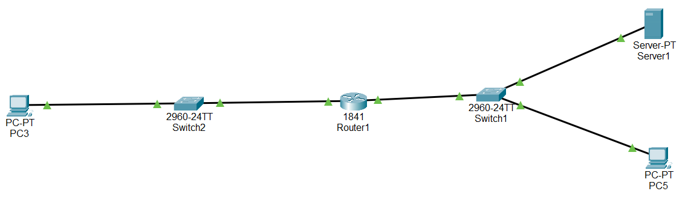

NOTE : I USE ADDITIONAL PC FOR CHECH AN APPLICATION SERVER FROM WEB BRWSER AND I ADDED A SWITCH FOR FUTURE ADDING PC AND SERVICES.

**Steps:**

**Gateway Router:**

* Router1>enable
* Router1#configure terminal
* Router1(config)#interface fastethernet 0/0
* Router1(config-if)# ip address 192.168.18.1 255.0.0.0
* Router1(config-if)#no shutdown
* Router1(config-if)#exit
* Router1(config)#interface serial 0/1
* Router1(config -if)#ip address 192.168.118.1 255.0.0.0
* Router1(config-if)#no shutdown
* Router1(config-if)#exit

Desktop (pc):

* Click the pc and open it go to the desktop>IP Configuration > change to static>set IP address.

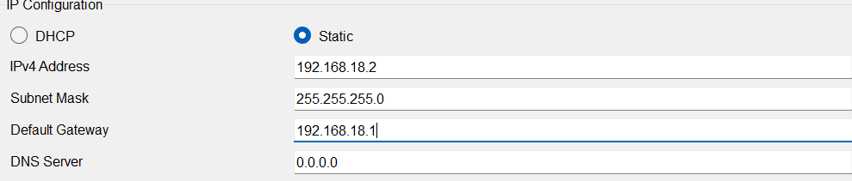

* Set all PC for this.
* And ping 192.168.18.1

APPLICATION SERVER:

* Click the application server and open it go to the desktop > IP configuration>change to static>set IP address.
* Click the application server and open it go to the service > Click HTTP >Turn ON HTTP and HTTPS > add HTML page in application server.
* Same Top Image But change IP to 192.168.118.2
* Click the application server and open it go to the desktop > Web Browser >Type the IP address 192.168.18.2

2. IP ADDRESS TABLE

|  |  |  |  |
| --- | --- | --- | --- |
| Device | Role | IP Adress | Subnet mask |
| Desktop VM  (Ubuntu Desktop) | Management | 192.168.18.2 | 255.255.255.0 |
| Gateway Router VM (enp0s3)  (Ubuntu Server) | Internet Access | 10.0.3.16 | 255.255.255.0 |
| Gateway Router VM (enp08) | Subnet 01 – internet Network | 192.168.18.1 | 255.255.255.0 |
| Gateway Router VM (enp0s9)  (Ubuntu Server) | Subnet 02-Internet Network | 192.168.118.1 | 255.255.255.0 |
| Application Server VM (Bitname) | server | 192.168.118.2 | 255.255.255.0 |

3. GIT PAGES LAB REPORT

Github Project link - [**https://bhavya-143.github.io/Bhavyasri-sandbox/**](https://bhavya-143.github.io/Bhavyasri-sandbox/)

Github File Link - <https://github.com/bhavya-143/Bhavyasri-sandbox.git>

**Configuration Steps:**

You need to create three VM mechine’s for this project.

* Download the virtual box and install in your PC.
* Download the three OS for project.
  + Ubuntu Desktop (.iso format) or our Desktop OS like (kali linux,windows)
  + Ubuntu server OS (.iso format).
  + Appiication server in Bitnami Wordpress(.ova format).

Add three OS in virtual box.

**Ubuntu Server OS configuration steps:**

**Step 1: create a new virtual machine (VM) for ubuntu server**

Open virtualbox.

Click on new to create a new virtual machine.

Name the VM

Select the type as linux and the version as ubuntu(64-bit).

Allocate memory (RAM) for the VM (e.g.,2048 MB or higher based on your system’s capacity).

Choose to create a virtual hard bisk now and set a sufficient disk size(e.g., 10GB).

Click create.

**Step 2 :configure the network interfaces**

You need two network interface on the Ubuntu server VM to act as a router between the two subnets.

* + Go to settings of your new VM.
  + Select network.

**Adapter 1:** set to internal network (name it differently, e.g., intnet).This will be your subnet.

1.click the advanced tab and set the adapter type to PCnet- FAST or another supported type. Note: within the ubuntu server terminal, this card will typically have a network adapter name of enp0s8.

**Adapter 2 :** Enable this adapter and set it to another internal network (name it differently, e.g., intent 1).this will be for subnet 2 within the ubuntu server terminal, this card will typically have a network adapter name of enp0s9.

**Adapter 3 :**set to NAT . Note :within the ubuntu server terminal, this card will typically have a network adapter name of enp0s3.its IP address will be assigned via DHCP . it will be used to provide access to the internet via the host computer.

**Step 3: install Ubuntu server**

State the VM and select the Ubuntu server ISO as the boot disk.

Go through the installation process:

Set your time zone, keyboard layout, etc.

When asked, select the option to install OpenSSH server (to enable remote access later if needed).

Complete the installation, then reboot the VM.

**Step 4: configure static Ips on the network interfaces**

After installation, you’ll need to assign static IP addresses to both network interface( each in different subnets).

Log in to the Ubuntu server VM.

Edit the network configuration file:

* Sudo nano/etc/netplan/00-installer-config.yaml

Type this code.

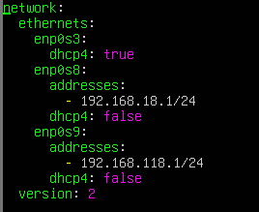

Save it (CTRL+X) type(yes) and enter.

Apply the network changes

* Sudo netplan apply
* Ip a

**Step 5: enable IP forwording**

To allow routing between the two subnets,you need to enable IP forwording.

Open the sysctl configuration file:

* Sudo nano/etc/sysctl.conf

Uncomment the line (or add it if not present):

* Net.ipv4.ip_forword=1

Apply the changes:

* Sudo sysctl -p

**Step 6: set up IP table for routing**

You may also want to configure iptables to ensure packet are foeworded between the subnets.

**Configured iptables to allows forwording:**

* + Sudo iptables -A FORWORD – I enp0s3 -o enp0s8 -j ACCEPT
  + Sudo iptables – A FORWORD -I enp0s8 –o enp0s3 -j ACCEPT

To make the changes permanent, you can save the iptables rules:

* + Sudo apt install iptables -persistent
  + Sudo netfilter- persistent save
  + Sudo netfilter- persistent reload

**Ubuntu OS configuration Steps:**

**Step 1: installing Ubuntu Desktop in VM**

To create a virtual machine and install a GUI -based OS from an ISO file

Launch virtual box

Click “New” to create a new machine

Fill in the details as requested so that the new machine is:

* + Name “ubuntu desktop”
  + The ISO name “ubuntu-24.04.1 – desktop-amd64.iso” is selected
  + The checkbox for “skip unattended installation” is checked.

Click “Next”. Now ensure the machine has:

* + 2048mb of base memory
  + Two processors

Click “next” create a virtual hard disk for the machine. This will need to be a minimum of 25GB

Click “next”. Verify your settings are as above and click “finish”.

Click “install ubuntu”

You need to create an ubuntu account and click a restart now.

**Step 2: configure the network interfaces:**

You need one network interfaces on the ubuntu desktop VM.

Go to setting of your new VM

Select Network.

**Adapter1:** set to interface network (name it differently, e.g., intnet).

Open ubuntu desktop in VM and login.

Go to setting >network>enp0s3 setting> IPV4 >IPV4 method change (manual)> Add address=192.168.18.2, add netmask= 255.255.255.0 , add gateway =192. 168.18.1 click Apply.

**BITNAMI WEB APPLICATION CONFIGURATION STEP:**

To create a bitnami virtual machine using virtual box

**Step 1: install bitnami application in VM.**

Click “file” the “import application”.

Navigate to the file name “bitnami -wordptress-6.3.1- r0 – dedian-11- amd64.ova”

Click “open”.

Click” Next”

Click” finish”

Click ”start” to launch the machine.

The first- time log in details is display on- screen. You will be required to reset the password on your first log in.

Close the bitnami.

**Step 2: configure the network interface**

Go to settinh of your new VM.

Select network.

**Adapter 1 :**

set to interface network

Open bitnami application in VM and login.

Type the code

* Sudo nano/etc/network/interfaces

Auto enp0s3

face enp0s3 inet static

Address 192.168.118.2

Netmask 255.255.255.0

Gateway 192.168.118.1

* Save it (CTRL +X ) type (yes) and enter.
* Sudo ifdown enp0s3 && sudo ifup enp0s3
* Sudo systemctl restart networking
* Ip a

4.FUNCTION TEST RESULTS

Evidence that all VMs can communicate as per the design.

**Ubuntu Server OS:**

Network IP configuration For Ubuntu Server.

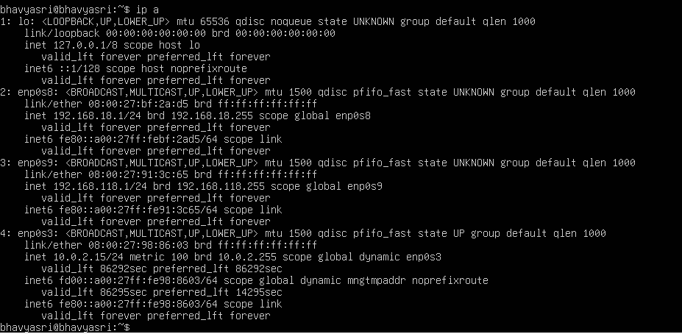

Ping Ubuntu Server to Ubuntu Desktop Using IP address 192.168.18.2.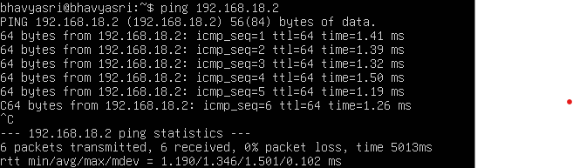

Ping Ubuntu Server to Bitnami Application Server Using IP address 192.168.118.2.

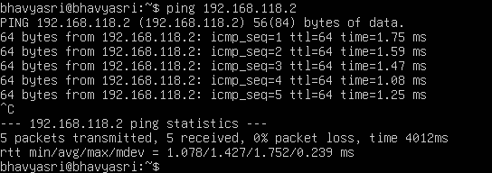

**Ubuntu Desktop OS:**

Network IP configuration For Ubuntu Desktop.

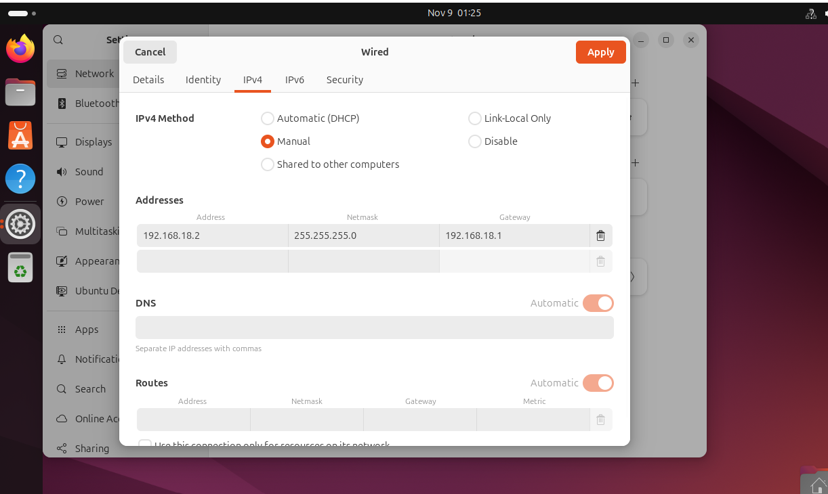

Ping Ubuntu Desktop to Ubuntu Server Using IP address 192.168.18.1.

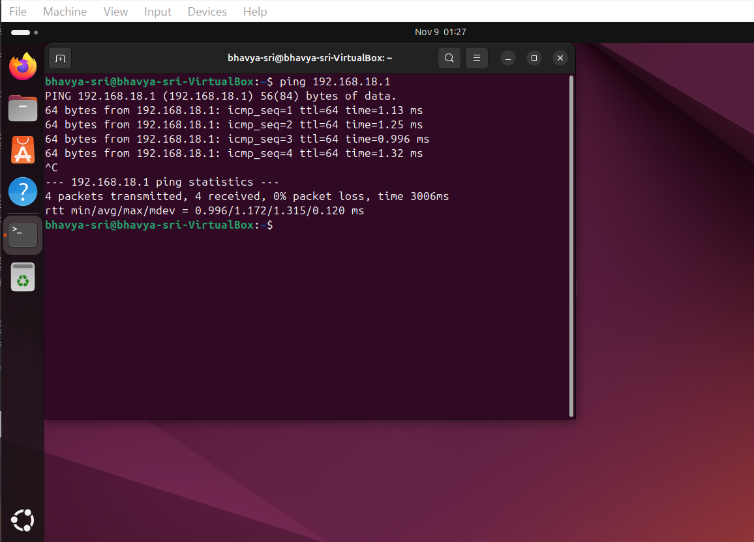

**Bitnami Application Server:**

Network IP configuration For Bitnami Application Server.

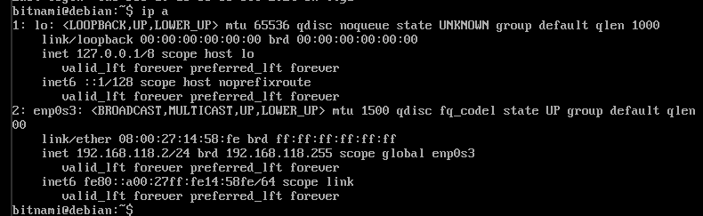

Ping Bitnami Application Server to Ubuntu Server Using IP address 192.168.118.1.

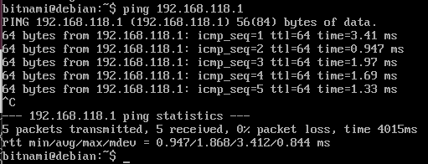

The Demo Video Youtube link - <https://youtu.be/cVIimRIDabI>